**ASSIGNMENT-32.2:**

Creating a table named ‘Custom1’ with two column names and inserting the values:

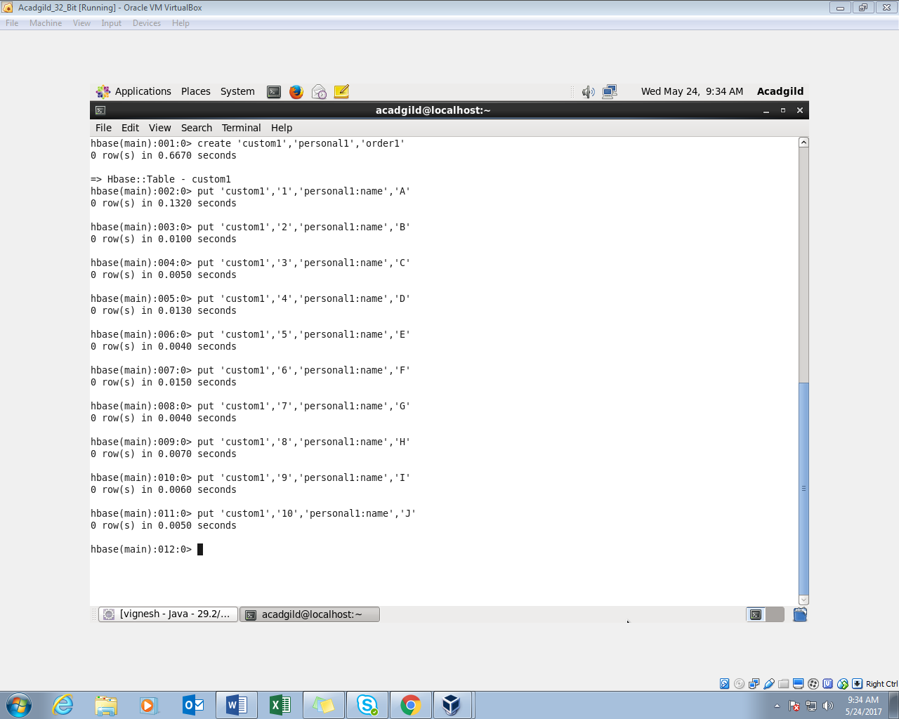

Inserting the data into the table using the ‘PUT’ command:

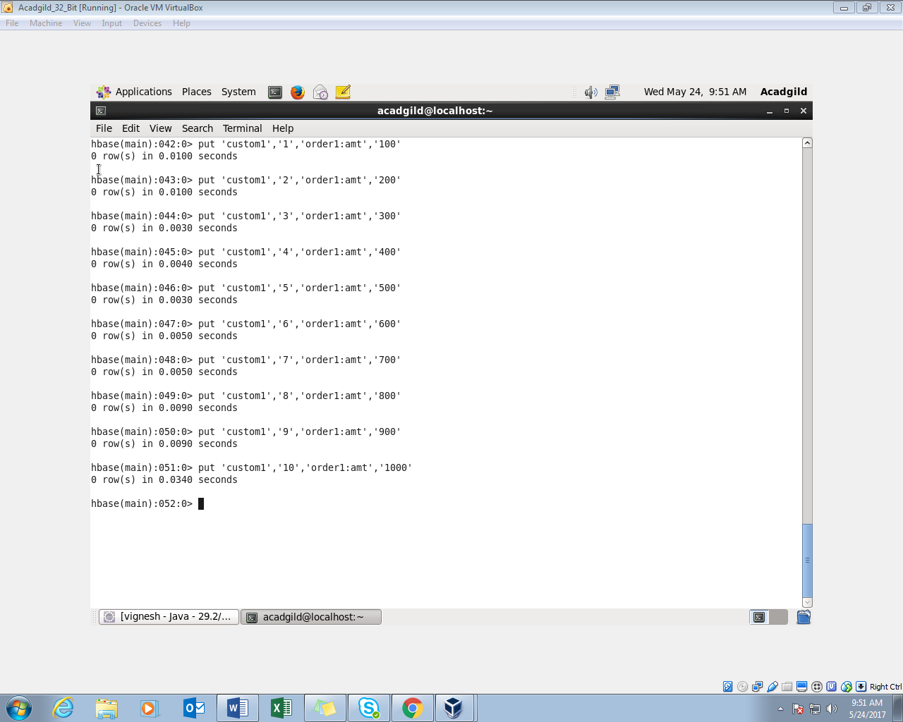

To extract the data from the table, enter the table name and the row key number

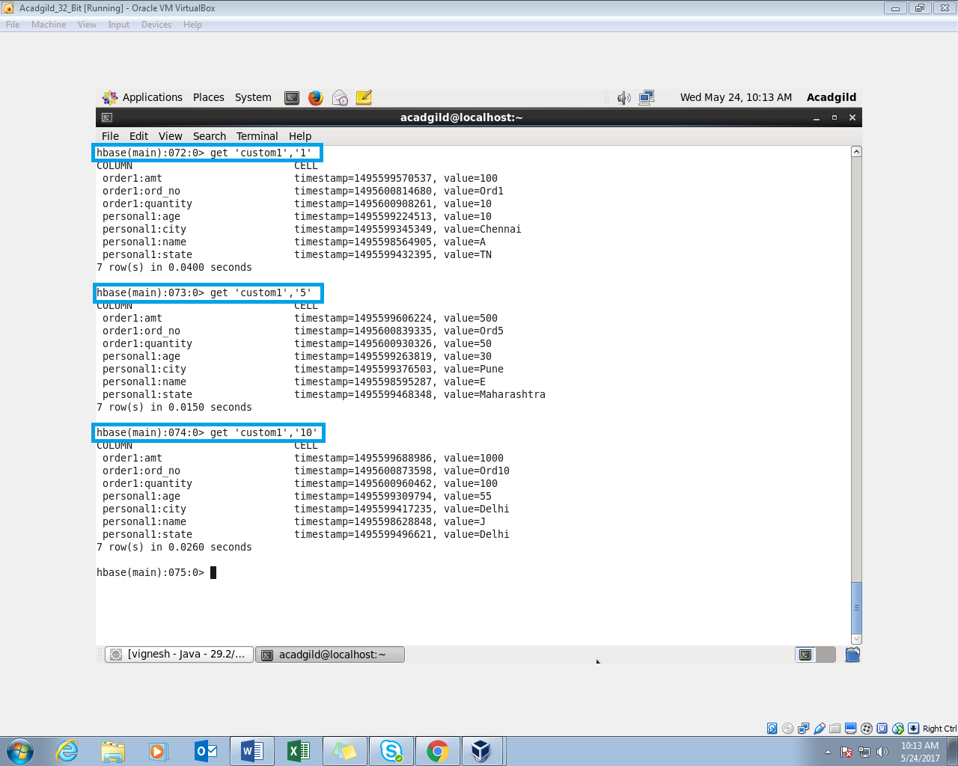

To display the entire details of the table “SCAN” command is used

